RESOLUTION NO.__________

RE: CERTIFICATE OF APPROPRIATENESS UNDER THE
PROVISIONS OF THE ACT OF THE PENNSYLVANIA
LEGISLATURE 1961, JUNE 13, P.L. 282 (53
SECTION 8004) AND BETHLEHEM ORDINANCE NO.
3952 AS AMENDED.

The applicant proposes to install new roof, gutters, garage doors, rails on flat roof, storm windows and wood exterior trim at 241 E. Market St.

NOW, THEREFORE, BE IT RESOLVED by the Council of the City of Bethlehem that a Certificate of Appropriateness is hereby granted for the proposal.

Sponsored by: (s)

(s)

ADOPTED BY COUNCIL THIS DAY OF

(s)
President of Council

ATTEST:

(s)

City Clerk

HISTORICAL & ARCHITECTURAL REVIEW BOARD

The applicant proposes to install new roof, gutters, garage doors, rails on flat roof, storm windows and wood exterior trim at 241 E. Market St.

APPLICATION #1:

Campbell Real Estate
130 W. 4th. St.
Bethlehem, PA 18015

OWNER:

__________________________________________________________________________

The Board upon motion by Phil Roeder and seconded by Marsha Fritz adopted the proposal that City Council issue a Certificate of Appropriateness for the following:

- Removal of the ramp and re-using the metal rail at the steps.

2. The exterior trim to include 5/4” x 4” sills.

3. The re-use of the shutters.

4. The addition of trim and rail at the roof edge.

5. New roof, siding and doors at the three-car garage.

6. The motion was unanimously approved.

__________________________________________________________________________

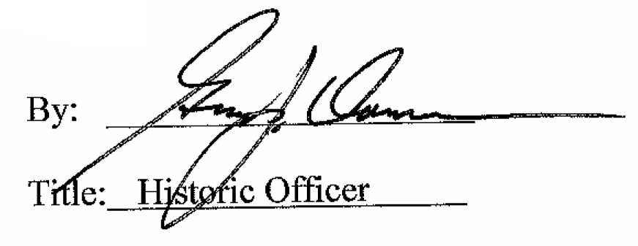

Date of Meeting: March 14, 2018

